
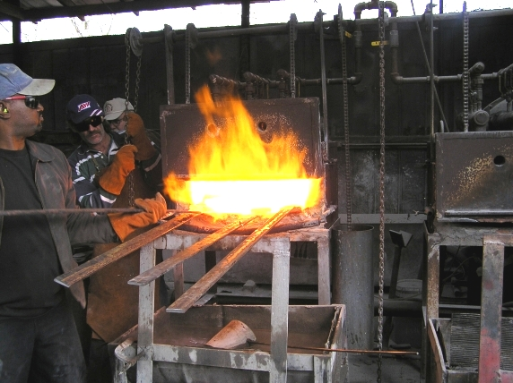
February 2007
Flint River Knife Club
mullikim@earthlink.net
Making Damascus!

CLUB TRIP: The Club went to Alabama to the shop of Brad Vice. He showed us around his shop , then gave a demonstration at his forge. Although the weather was a bit nippy, everyone had a good time. Thanks, Brad, for having us!

FUTURE EVENTS: The Club is raring to do things this year! We will have another trip this year, perhaps to the National Knife Museum in Tennessee. We will also have picnics with demonstrations. The next event – mark your calendars! – is a picnic on Saturday, April 28. Rade and June Hawkins will host it.

MEETING PROGRAMS: Each member will be responsible for a program for one of the meetings. You can do it yourself or ask someone to come to the meeting and give a talk or demonstration. Please see the Secretary, Cheryl Mullikin, to sign up for a particular month. Those members who did not do a program last year are requested to be the first to present one this year. These programs make the meetings more interesting and we can learn so much from each other.
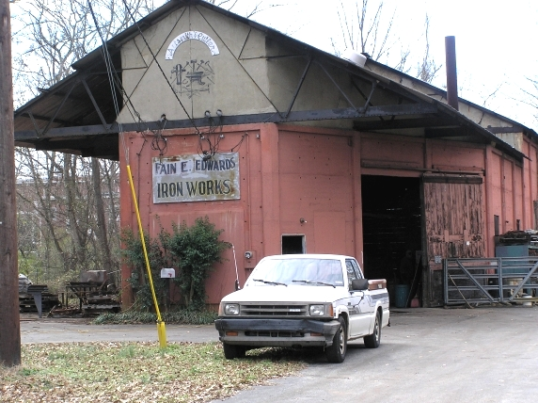
CLUB SCHOLARSHIPS: The Club voted at the last meeting to extend the time that recipients of the Club’s scholarships can fulfill their request. They will have until the end of the following year when they won the scholarship. (i.e. 2006 winners have until the end of 2007; 2007 winners have until the end of 2008 and so on.)

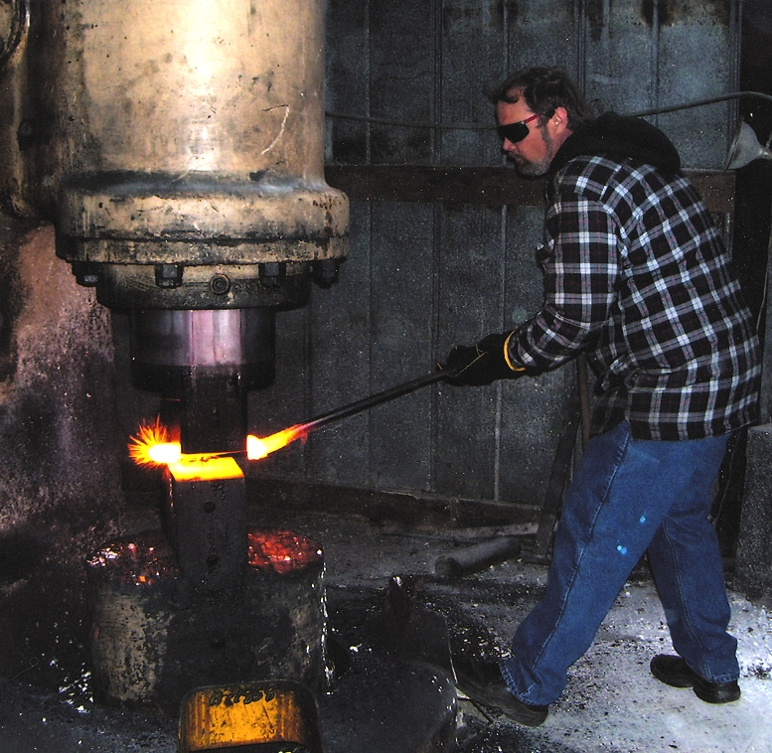
Jack Jackson won the drawing for a scholarship at the January meeting. He wants to attend the Basic Knife Making Class at the Montgomery Community College in August.

Here is a link for the 2007 schedule for knife making classes at Montgomery Community College in Troy, NC.

http://www.montgomery.cc.nc.us/cenra.htm
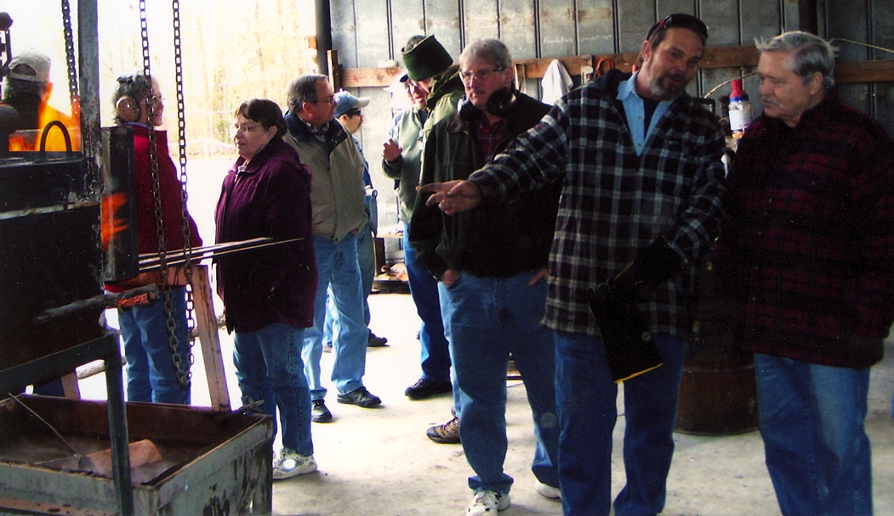
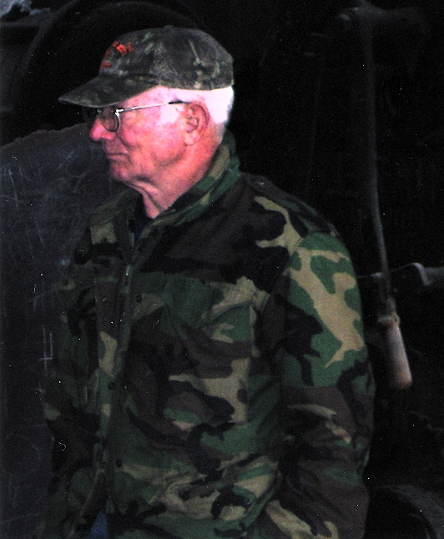
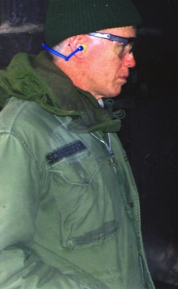
Next
Meeting!

Tuesday, Feb. 6 at the First Baptist Church of Jonesboro at 7 p.m.

